[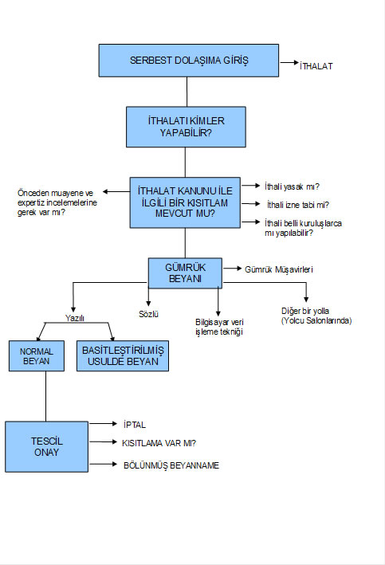](http://muhasebeden.com/wp-content/uploads/2013/04/gumruk-is-akisi.jpg)