[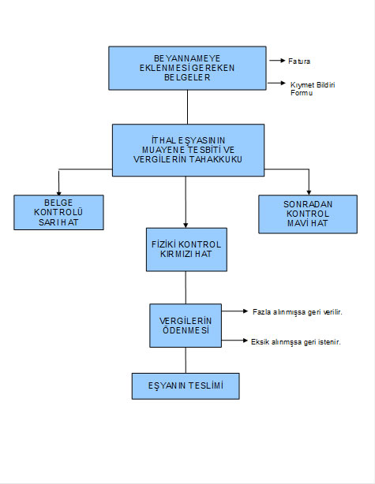](http://muhasebeden.com/wp-content/uploads/2013/04/ithalatta-gumruk-islemleri.jpg)