[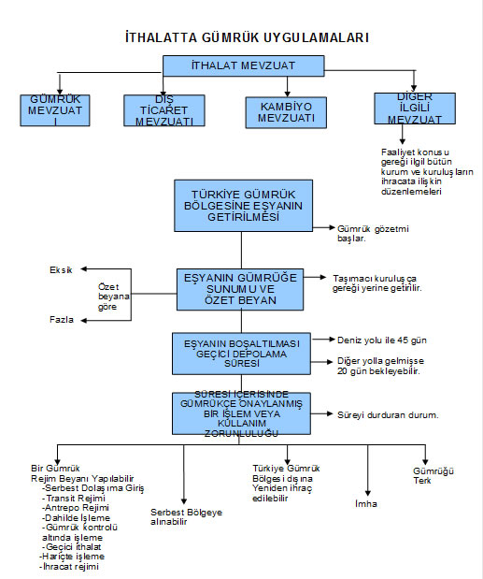](http://muhasebeden.com/wp-content/uploads/2013/04/gumruk-uygulamalari.jpg)