İHRACAT

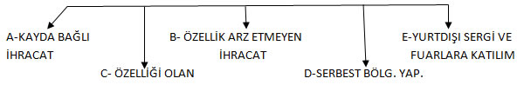İHRACAT İHRACAT

