[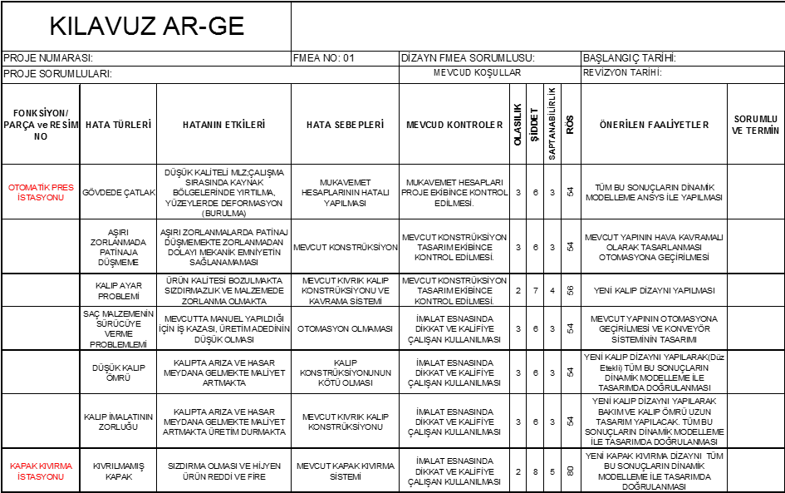](http://muhasebeden.com/wp-content/uploads/2014/06/FMEA.png)