[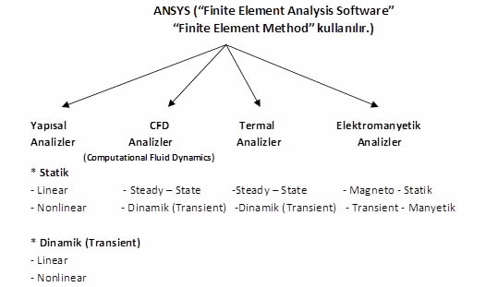](http://muhasebeden.com/wp-content/uploads/2014/06/tablo-kosgeb.jpg)