**FEM ANALİZLERİ**

[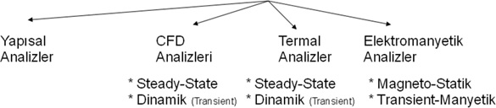](http://muhasebeden.com/wp-content/uploads/2013/04/bilgisayar-ortami.jpg)