TRL YA DA TOS’UN BAĞLANTILARLA AÇIKLANAN RESMİ

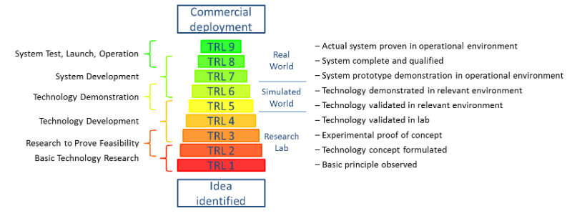

Kaynak link: https://www.linkedin.com/pulse/9-secrets-top-5-sme-instrument-winners-kristjan-zemljic

